**Overall response summary**

**Regarding an appeal- you are welcome to do this. For an appeal I suggest that you provide a point-by-point response to the editors’ concerns and all of the reviewers' comments and/or a revision plan on how you will address them.**

**If you decide to appeal, could you please send this to me by email when it is available? Please note that it is not necessary to revise the manuscript at this point, and please do not re-submit the manuscript on the submission system. I will then discuss this with the editorial team before conveying a decision on whether to grant this appeal. Please note that we do not expect any further analyses to address the reviewers’ comments at this stage, just a plan on how you will address them.**

Dear Ming,

Thank you for the review of our paper “Trends and Disparities of Dangerous Humid Heat Exposure Among Incarcerated People in the United States” (NMED-BC127675) and for the possibility of appealing the original decision to transfer the paper to Nature Sustainability or Nature Human Behaviour.

We acknowledge, and are happy, that the three Reviewers collectively have expertise in the different and relevant substantive and methodological aspects of the paper. Our appeal of the decision is therefore premised on two points: (1) the comments are addressable in substantive, methodological and presentational revisions, while maintaining the paper’s novel scope and interesting findings relevant to climate change and environmental and social justice, as well as broader public health and medical fields, and (2) this paper is appropriate for Nature Medicine, since our findings are directly relevant to the health of people who are incarcerated in the United States, and has direct implications for both primary and secondary prevention of humid-heat related adverse health outcomes, especially in the context of climate change and environmental justice.

To summarize feedback from Reviewers, Reviewer 1 explicitly stated the manuscript is worthy of publication after edits, Reviewer 2 has made clear achievable suggestions, and Reviewer 3 said their assessment of the paper is ‘strongly positive’.

We provide details below on the proposed revised analysis based on the comments from Editors and Reviewers. Each of the changes requested by all of the Reviewers’ comments are eminently addressable.

In brief, we can realistically carry out substantial additional work and we will:

1) Address questions about our use of wet bulb globe temperature (WBGT), including (i) performing sensitivity analysis across multiple WBGT thresholds, (ii) testing our assumptions with US National Weather Service heat index thresholds for heat warnings, and (iii) benchmarking our PRISM-derived data against ERA5 reanalysis data, with which we have substantial previous and expertise and experience, per Reviewers 1 and 2;

2) Update the context of our study to better incorporate health-relevant discussion conclusions, and compare the findings of a previous PLOS One study, as well as make clearer how our work is distinct and novel, per Reviewer 2;

3) Address questions related to carceral facility locations and the urban heat island effect, per Reviewers 1 and 2;

4) Revise language for consistency related to carceral facilities and better address the environmental literature, per Reviewer 3, and risk to health outcomes, per Reviewer 2; and

5) Adding a richer description of methods and additional figures in revised Supplementary Information, as per all Reviewers.

We thank you again for giving us the opportunity to appeal the decision and look forward to your response.

Sincerely,

Cascade Tuholske, PhD (he/his)

Asst. Professor of Human-Environment Geography

Dept. of Earth Sciences

Montana State University

Robbie M. Parks, PhD (he/his)

Asst. Professor of Environmental Health Sciences

Mailman School of Public Health

Columbia University

**Editors’ Comments**

**While the referees find the topic is of importance, they raise concerns with regards to the conceptual advance of the study, the lack of health outcomes investigated as well as the modelling of humid heat conditions. We feel that these reservations are sufficiently important as to preclude publication of this study in Nature Medicine.**

The comments made by the Editors and Reviewers are all realistically addressable and below we detail our point-by-point plan to respond to them. We will be able to carry out the required additional work and will improve the revised manuscript to address questions about the conceptual advance, health outcome relevance, and modeling of humid heat conditions.

**Reviewers' Comments:**

**Reviewer #1:**

**Remarks to the Author:**

**The article analyses the exposure to heat stress of incarcerated people in the United States, analyses the temporal changes in the exposures, and compares conditions between and within states. The article is interesting to a wide audience by addressing a topic of relevance affecting a vulnerable population subgroup in terms of social justice under the context of anthropogenic warming. In my opinion, the article is worth publishing, after taking into account the following recommendations.**

We thank the Reviewer for the thoughtful and constructive suggestions. We have responded point-by-point to how we will address the Reviewer’s questions and comments below.

**1) I personally disagree with the concept “dangerous humid heat exposure”. On the one hand, “dangerous” refers to the risk (that would be analysed through epidemiological methods), which is beyond the scope of the paper. WBGT=28 might not be dangerous for a young individual, while WBGT=27 will likely be dangerous for an elder person. The article addresses the exposure, and not the dangers or risks per se. This is particularly important for the trends, given that the demographic characteristics of the incarcerated population might have changed during the study period (age, sex, race, comorbidities, …), and thus their vulnerability to heat stress. On the other hand, the article does not strictly address the exposure to compound heat-humid conditions, which would typically be modelled by imposing at the same time a threshold to temperature and a threshold to humidity. The article only imposes one threshold to a derived variable, i.e. WBGT, and therefore it generally addresses the “exposure to heat stress“, which I must say is still an interesting scientific and social question.**

We will reframe the paper in terms of exposure to heat stress, while also adding a substantial discussion of the implications of the particular demographic risk these kinds of heat stress will add to incarcerated communities, as well as the additional risk of being incarcerated largely indoors without freedom to access cooling mechanisms.

We agree with the Reviewer that the level of ‘danger’ from exposure to humid heat is dependent on individual-underlying risk. We originally selected 28°C as it is an internationally-accepted threshold that is tied to heat-health physiological research, as well as comparable to international occupational heat health standards like International Standards Organization 7243 (https://www.jstage.jst.go.jp/article/indhealth/44/3/44_3_368/_article/-char/ja/) that allow our findings to be compared to studies worldwide. Such exposure thresholds are based on previous research about risk from prior bodies of evidence.

Nevertheless, we will also present sensitivity analyses of other thresholds (including 26°C, 30°C) as a comparison in the revised manuscript.

**2) In the appendix, I had problems to understand the procedure to calculate the WBGT (“Daily WBGTmax Estimates”) and the metrics (“Calculating humid heat exposure and trajectories of change metrics”). The authors refer to other articles (“described in full elsewhere” twice), and given that they do not have a word count limit, I would encourage them to give full details, and improve the description.**

We will add full details of the methods, previously used to calculate the daily WBGTmax estimates in several previous analyses, (e.g. <https://github.com/ecohydro/GlobalUrbanHeat>, [https://www.pnas.org/doi/abs/10.1073/pnas.2024792118,](https://www.pnas.org/doi/abs/10.1073/pnas.2024792118) and <https://www.tandfonline.com/doi/abs/10.1080/15459624.2014.989365>, in the revised Supplementary Information and will do so.

**3) Related to the calculation of the WBGT, I have concerns about the combination of Tmax and VPDmax to calculate WBGTmax, and the combination of Tmax and RHmin to calculate HImax. Given that the article is about the assessment of the exposure, and not the risks (see point 1 above), I consider that it is important to reduce the number of assumptions in the calculation of the exposure. In principle, as recognised by the authors, the time of the day when T and VPD are maximum is different, as well as the time of the day when T is maximum and RH is minimum. With daily data, such as PRISM, these assumptions are needed. But, with hourly data, this would not be necessary. This could be achieved with other databases, e.g. ERA5-Land, which is available hourly and globally at 9km resolution. The decreased spatial resolution (9km vs. 4km) might not be a major drawback, and it would certainly improve and simplify the procedure to calculate the exposure variables, which is central in the paper. Moreover, having two independent sources of climate data could be useful to quantify the uncertainties in the exposure estimates and the methods used to calculate them.**

We will discuss, based on a substantial new analysis and paper members of our authorship group wrote on comparing heat stress metrics generated from various data sources (<https://europepmc.org/article/ppr/ppr697139>), how our calculation of WBGT is a sensible option and compares to ERA-5 estimates, as well as present a discussion on the various ways heat stress can be measured.

**4) I particularly did not like the paragraph about El Niño and seasonal forecasting. ENSO is not the only source of seasonal predictability in the United States, and two El Niño events are not enough to infer seasonal predictability. I would suggest the authors to either remove the paragraph, or to perform specific analyses with seasonal forecasting data.**

We will remove this paragraph if the Editors agree.

**5) Figure 2a shows that carceral facility locations were exposed to higher heat stress than the corresponding states (i.e. disparities), and Figure 2b shows that the heat stress in carceral facility locations has increased (i.e. trends). I would add a third panel showing if the heat stress in carceral facility locations has increased at a higher rate compared to the corresponding states (i.e. disparities in trends, or trends in disparities). This would further increase the relevance of the paper.**

We will add a third panel as per the Reviewer’s request.

**6) In the discussion, I missed the following point: why carceral facility locations are systematically exposed to higher heat stress than the corresponding states? The only major exception is Florida (see Figure 2a), why? These are two non-trivial questions worth discussing. I would expect most carceral facilities located in non-urban areas, not affected by the urban heat island effect. I had problems to understand the description of the calculation of the disparities in the appendix, and the codes were not really helpful (I would suggest to share simpler sample codes with sample data), so I am not able to judge if there is a bug in the codes. I would suggest the authors to re-verify the codes, and if they are ok, discuss/justify these (counterintuitive) results.**

We will add discussions relevant to the locations of carceral facility locations, which vary by state, but largely are related to the availability of low-cost land and limited resistance of local communities. In many states, the areas that meet these criteria are in sparsely populated desert or swampy environments. We will also include a discussion of how zoning laws and security issues favor construction in isolated, desert-like areas and why older prisons are located in hot areas

(based on e.g., <https://www.prisonpolicy.org/blog/2022/04/20/environmental_injustice/>, <https://www.bloomberg.com/news/articles/2017-05-02/inside-the-prison-towns-of-the-rural-south>, <https://www.americanactionforum.org/research/incarceration-and-poverty-in-the-united-states/m>, <https://eos.org/features/an-unfought-geoscience-battle-in-u-s-prisons>).

We will revise the code to make following it more straightforward and intuitive. We have checked the code several times and do not believe that there is a bug there.

**7) In the discussion, I would discuss if the demographic characteristics of the incarcerated population in the United States have changed over the analysed period, e.g. changes in age, sex, race, comorbidities, with regard to the factors that typically make people vulnerable to heat stress (see point 1 above).**

We will describe demographic characteristics of incarcerated communities in the United States and provide context to how they have changed over time, based on <https://www.prisonpolicy.org/data/> and potentially other sources.

**Overall, I recommend that the article is published after these issues are considered. I congratulate the authors. Many thanks for this interesting piece of work.**

We once again thank the Reviewer.

**Reviewer #2:**

**Remarks to the Author:**

**In reviewing this article, I note that there is ongoing societal discourse, particularly by human rights organizations, on the issue of heat-related deaths in prisons. Documented cases of such deaths have been reported in states such as Arizona, California, Florida, and Texas, leading to calls for reforms to protect inmates from extreme heat conditions.**We thank the Reviewer for the thoughtful and constructive suggestions below. We agree that there is a lot of societal discourse about this topic, and we propose that there is a strong need to highlight the national analysis of heat-related stress exposure in United States carceral facilities, from a disparity perspective, which has not previously been comprehensively analyzed.

We have responded point-by-point to how we will address the Reviewer’s questions and comments below.

**I find parallels between this study and a publication in PLOS One, which analyzed data on mortality in U.S. state and private prisons from 2001 to 2019, linked to daily maximum temperature data for the summer months. The study, using a case-crossover approach and distributed lag models, estimated the association of increasing temperatures with total mortality, heart disease-related mortality, and suicides, and examined the association with extreme heat and heatwaves. The study found that a 10°F increase was associated with a 5.2% increase in total mortality and a 6.7% increase in heart disease mortality. The association between temperature and suicides was delayed, peaking around three days prior to death. So I look forward to the vulnerabilty analysis of this paper.   
(Reference: 10.1371/journal.pone.0281389)**

Our analysis substantially adds to the existing body of knowledge on this topic, with full acknowledgement of previous literature. Particularly, the PLOS One study focuses on mortality, which is certainly valuable. However, in the carceral facility and heat context, there are other major impacts to health and wellbeing; our focus on exposure with a direct relevance on health allows us to be more broad in focus.

The analysis we present in this manuscript is totally distinct from previous publications for several reasons, including the previously-unquantified growing disparities and inequities in humid heat stress throughout the United States, which has previously not been summarized in the context of climate change-related trends.

In particular, we present the new findings, including:

* During 2016 – 2020, on average annually, there were 41.25 million person-days of exposure at US carceral facilities, with the greatest contribution from state prisons (61%);
* There was a consistent disparity during 1982 - 2020, with carceral facilities exposed to an average of 5.5 more dangerous humid heat days than the rest of the US annually;
* An estimated 915,627 people (45% of total) are incarcerated in 1,739 facilities that experienced an annual increase in the number of dangerous humid heat days per year during 1982 – 2020; and
* Southern US facilities exhibited the most rapid warming, though many of these states do not mandate access to air conditioning for incarcerated people.

All of these details are previously unquantified and we add much needed information about which carceral facilities in the United States are in locations warming the fastest, and thus are in urgent need of adaptations to reduce harm to incarcerated peoples. We will further contextualize the findings of our Brief Communication within the findings of the PLOS One manuscript and expound future research directions.

Further, we are making all of the data publicly available via <https://github.com/rmp15/temperature_prisons_2023>, which will allow other researchers to build upon our work in this topic.

**Factors such as geographic location, infrastructure, inmate demographics, and prison policies play a crucial role in shaping heat-related outcomes. It is noteworthy that the facilities primarily at risk of experiencing dangerous heat conditions are located in the Southern United States, which are among the areas hardest hit by heatwaves. Thus, location/factor-specific information is key to making more precise guidelines.**

We agree with this and will add location-specific examples to our discussion, including how the Southern United States faces the greatest heat stress and the region contains potentially more vulnerable incarcerated communities compared to the rest of the United States.

**I do have a couple of questions for the authors:**

**1. Why did the authors choose to use the NIOSH definition of dangerous humid heat frequency, defined as the number of days per year where the maximum wet bulb globe temperature (WBGTmax) exceeded 28°C, the threshold used for acclimated populations to limit humid heat exposure under moderate workloads (234–349 W)? Given that WMO and NOAA both have heat wave definitions, wouldn't these be more comprehensive?**

We use the NIOSH WBGT threshold because it is tied to heat-heath physiological research, as well as comparable to international occupational heat health standards like International Standards Organization 7243 (<https://www.jstage.jst.go.jp/article/indhealth/44/3/44_3_368/_article/-char/ja/>) that allow our findings to be compared to studies worldwide.

Nonetheless, we agree with the reviewer that a sensitivity analysis will make our findings more robust. Thus, we will rerun our analysis using other WBGT heat-stress standards, like ISO WBGT>30°C and WBGT>26°C, ISO’s lowest threshold for heat risk (<https://www.jstage.jst.go.jp/article/indhealth/44/3/44_3_368/_article/-char/ja/> and the US National Weather Service’s (NWS) heat warning thresholds (<https://www.weather.gov/safety/heat-index>). We note that NWS thresholds vary regionally, but national-level research in the United States typically follows NWS threshold of two days or longer periods where HI>105°F, which is the heat index threshold we will use in our sensitivity analysis.

**2. Why did the authors not analyze the urban heat island effect? Is there a higher impervious surface area around prisons that could contribute to this phenomenon?**

We will add discussions relevant to the locations of carceral facility locations, which vary by state, but largely are related to the availability of low-cost land and limited resistance of local communities. In many states, the areas that meet these criteria are in sparsely populated desert or swampy environments. We will also include a discussion of how zoning laws and security issues favor construction in isolated, desert-like areas and why older prisons are located in hot areas

(based on e.g., <https://www.prisonpolicy.org/blog/2022/04/20/environmental_injustice/>, <https://www.bloomberg.com/news/articles/2017-05-02/inside-the-prison-towns-of-the-rural-south>, <https://www.americanactionforum.org/research/incarceration-and-poverty-in-the-united-states/m>, <https://eos.org/features/an-unfought-geoscience-battle-in-u-s-prisons>).

**3. In addition to exposure, where are the relative risks of health outcomes? It is not informative if we only have exposure, as Nature Medicine is a health-focused journal and we need to see health outcomes.**

Heat stress is an inherently health-relevant exposure, particularly in our current climate crisis. We suggest adding a brief and detailed discussion about health outcomes in the context of this is a valid further work.

As a Brief Communication, the purpose of this work is to highlight rapidly emerging and hugely impactful health-relevant issues, which we argue this work clearly does. Nevertheless, if the Editors would require, we would be able to add a risk assessment about estimated attributable mortality and morbidity based on previous risk estimates, though it would be a lengthy addition, and would stretch the facility for this article to be a Brief Communication.

**Reviewer #3:**

**Remarks to the Author:**

**This is an excellent paper on an important topic for which data and action are urgently needed. The authors applied rigorous methods and did a superb job describing their findings. There are a few clarifications that I think would strengthen the manuscript, but my overall assessment is strongly positive.**

We thank the Reviewer for the thoughtful and constructive suggestions. We have responded point-by-point to how we will address the Reviewer’s questions and comments below.

**1) Throughout the manuscript I think the authors need to be careful of their use of “incarceration” and “prison” because the facilities in the database include jails, prisons, immigration detention centers, and other types of carceral facilities. Each of these types of facilities have differences across their populations, durations of incarceration, and systems for regulation and accountability. For example:**

**a. “county prisons” (line 76) is not quite accurate, because most of the county-run facilities in the US are jails, not prisons. This issue also recurs in the supplemental materials, Cook County Jail is a jail not prison.**

We will correct terminology to ‘county jails’ throughout the revised manuscript.

**b. Immigration detention facilities are included in the HIFLD data and I think should be mentioned in the definition of carceral facilities (line 55) for purposes of clarity and action, even though there are relatively fewer of these facilities, because most readers will not know this context.**

We will add mention of immigration detention facilities, as well as supplementary figures that specifically examine particular facilities types (including ICE) (below) in the revised manuscript.

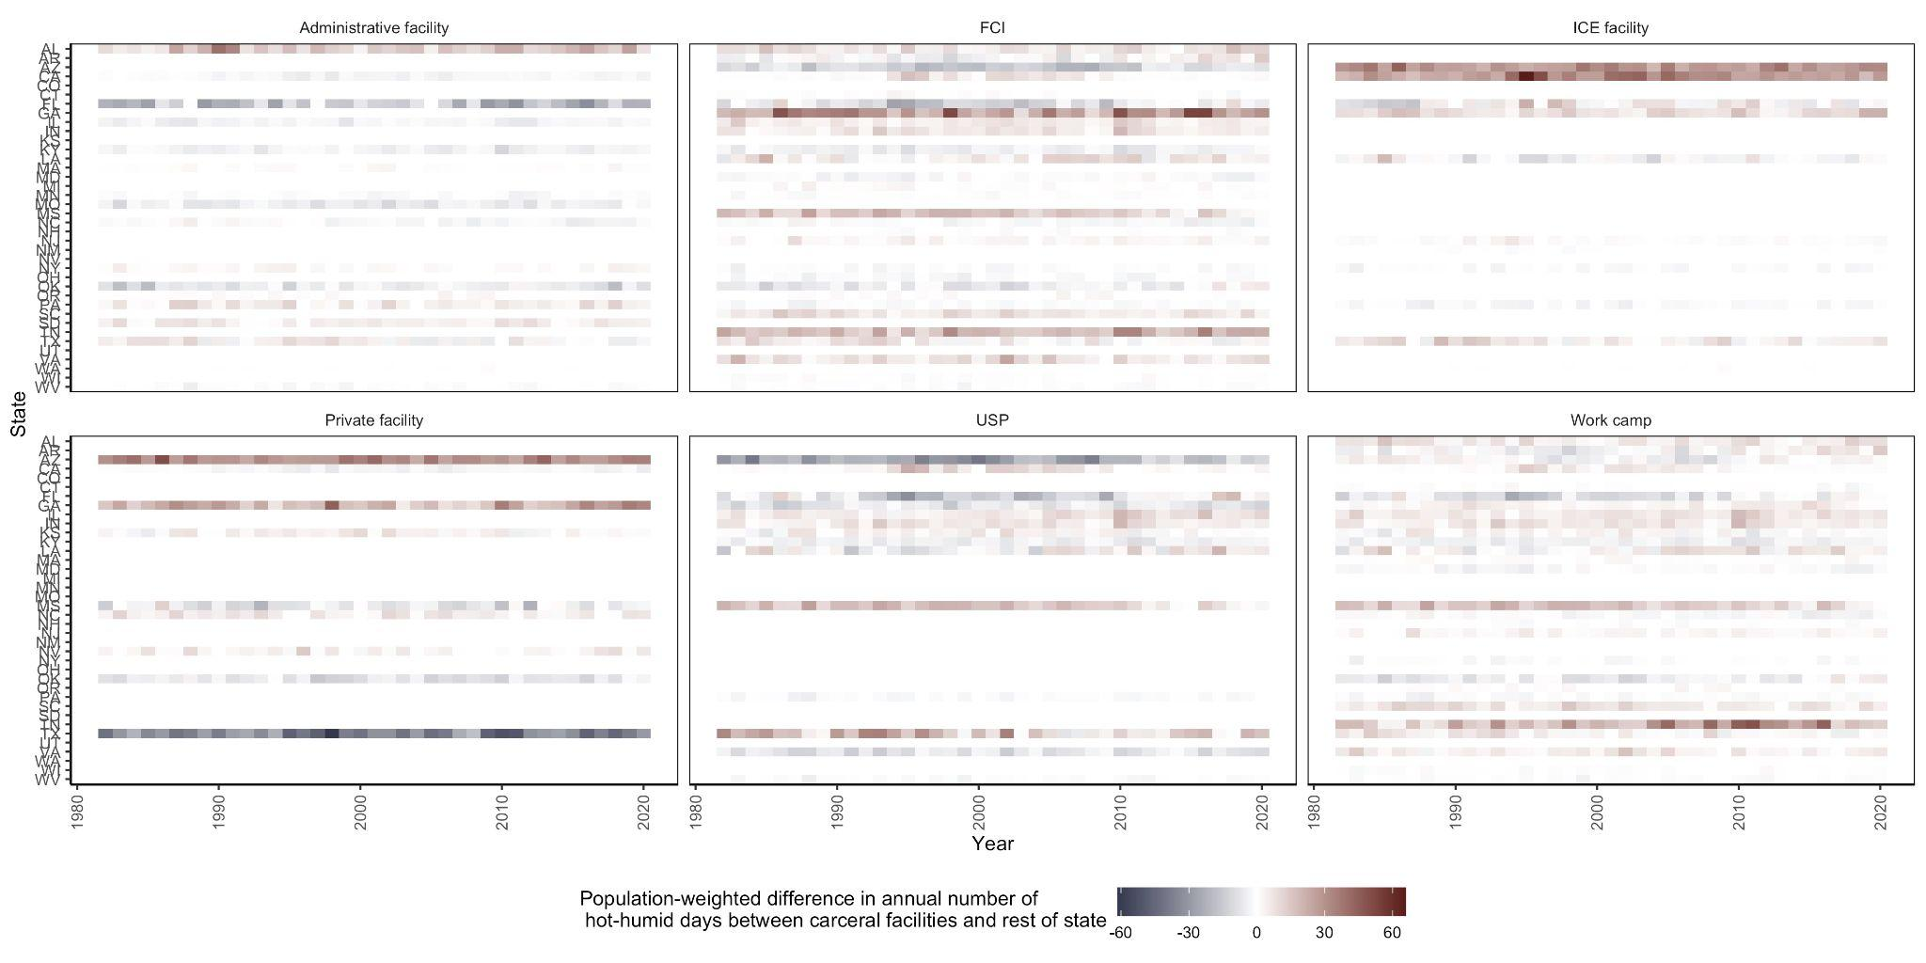

**Supplementary Figure.** The population-weighted difference between the annual number of days with heat stress conditions (defined as WBGTmax exceeding 28°C) at the location of **Federal** carceral facilities (Administrative, Federal Correctional Institution (FCI), Immigration and Customs Enforcement (ICE), Private, United States Penitentiary (USP), and Work camps) versus all other locations in the continental United States from 1982 - 2020 stratified by state.

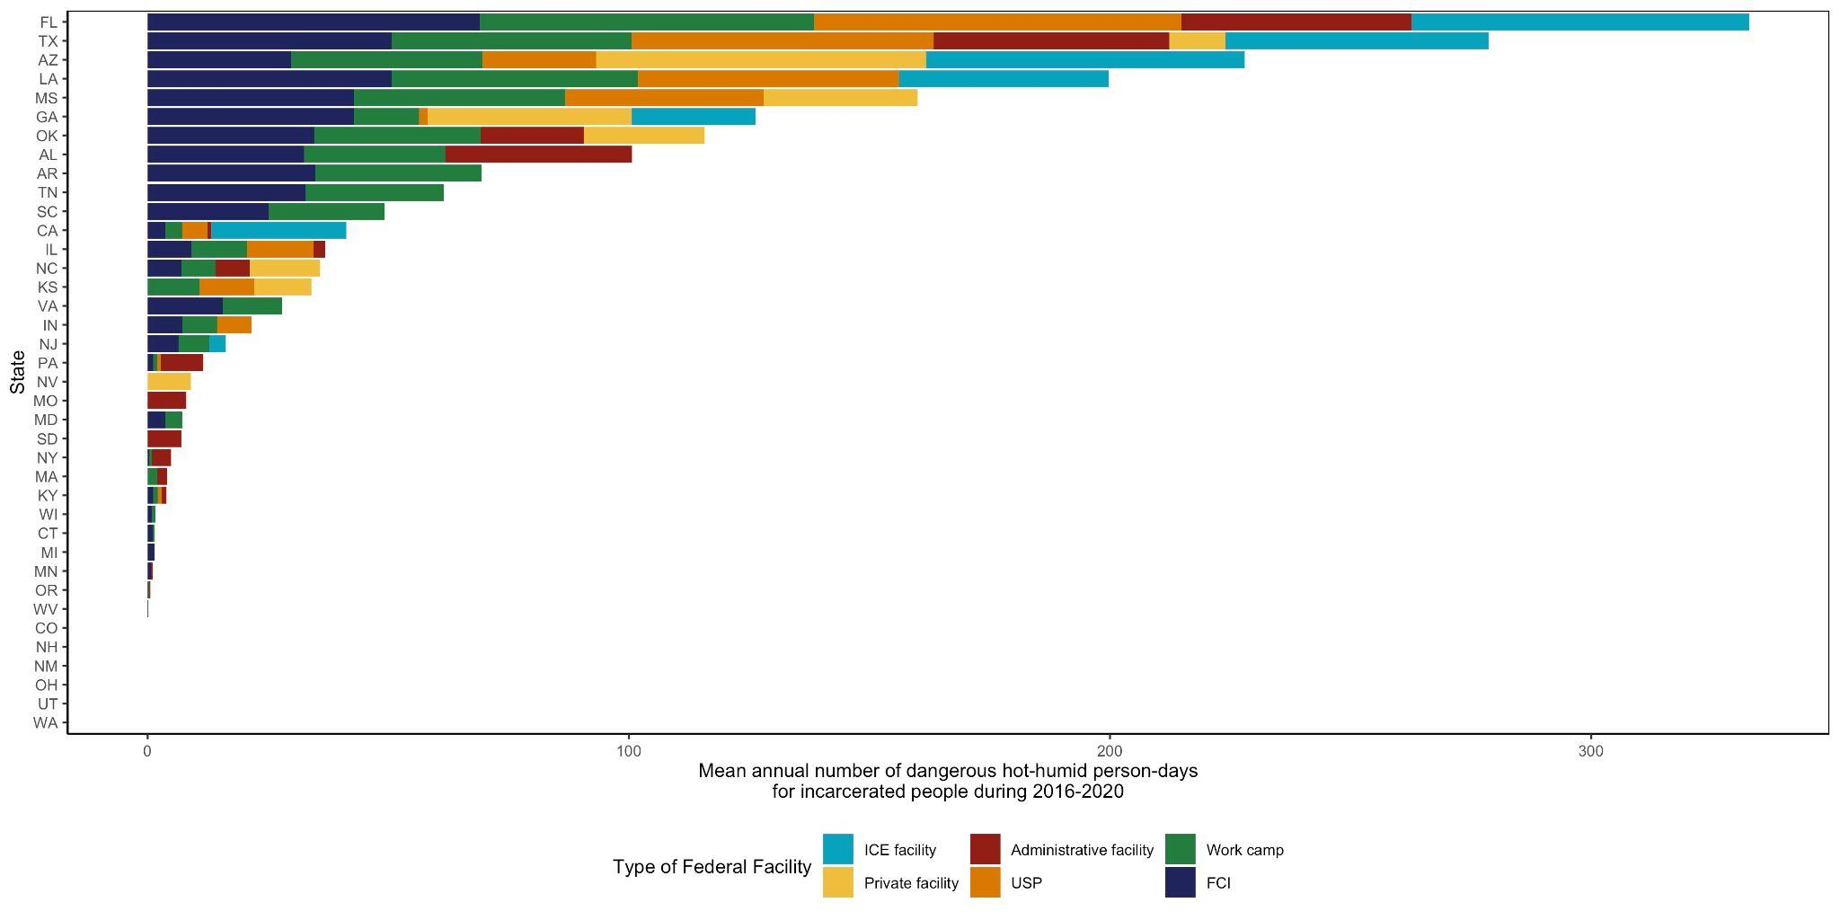

**Supplementary Figure.** Mean annual exposure during 2016 - 2020 to heat stress conditions in **Federal** carceral facilities within the continental United States (N = 232), measured by the number of person-days WBGTmax exceeded 28°C for incarcerated people by state and Federal facility type (Administrative, Federal Correctional Institution (FCI), Immigration and Customs Enforcement (ICE), Private, United States Penitentiary (USP), and Work camps).

**c. “southern states have the highest incarceration rates in the U.S.” (lines 106-107) this is certainly true of the imprisonment rate (which is cited) but less true of jails (eg see** [**trends.vera.org**](http://trends.vera.org) **for a comparison of the two)**

We will include the difference between imprisonment rate and jailing rate in the revised manuscript.

**2) I appreciate the authors comparison of carceral facilities to non-carceral facilities, and that this difference is population-weighted. I do wonder, however, whether these estimates though should also be weighted by or otherwise adjusted for land mass. The area that carceral facilities occupy is just so much smaller than the entire rest of the state.**

We will argue that population-weighting is the most sensible option here, as it most reflects the experience of a population.

**3) Fundamentally this is a paper about mass incarceration and environmental (in)justice, and therefore structural racism really should be mentioned. Even if the analyses do not race-stratify, which I understand is not the objective of this paper, the conclusions about differential harm to incarcerated populations disproportionately impacts Black, Latine and Indigenous Americans. Structural racism is fundamental to the rise and perpetuation of mass incarceration; for heat-related health harms to change we (meaning researchers but also policy makers, media etc.) need to acknowledge and address the role of racism in upholding these harmful systems and practices.**

We will add a relevant description of the role of racism in differential vulnerabilities of humid heat to incarcerated communities.

**4) Lastly, It would be helpful to have Figure 2A be sorted by the average value (ie by average pop.-weighted difference in annual n hot-humid days over the study period) instead of alphabetically**

We will do this in the revised manuscript.